Shani Bornstein
Final Project
Road of Resistance: Three Women’s Journeys in Defying the Nazis, is a digital exhibit about three Jewish female resistance fighters, Frumka Plotnicka, Vladka Meed, and Hannah Senesh, during the Holocaust. There were many women who were at the forefront of some of the most dangerous resistance activities including groups of Jewish women that organized different forms of resistance across Europe. This project’s main objective is to narrate and evaluate three female fighters who risked their lives for their fellow Jewish brethren. A recurring theme that is examined throughout this exhibit is how each of these women had a chance to escape the Nazis, yet they remained or in one case returned to fight and help their communities. A secondary objective is to remove any common misconceptions that many people have that the Jews did not put up a fight against the Nazis.
Objectives:
In the field of Holocaust studies, the subject of women is only recently being explored and given significance. Often teenaged girls were the ones to undertake certain missions for the resistance because men were more identifiable as Jewish. The women engaged in various acts of resistance from smuggling arms into ghettos, warning Jewish communities of looming deportations, and secreting children out of the ghettos to the Aryan side. This digital exhibit’s primary objective is to educate the public about these women fighters and bring their stories to light. There are multitudes of reasons why these narratives have been overlooked. For instance, people are drawn to learn about the concentration and death camps such as the infamous Auschwitz more so than other events of the Holocaust. Some might want to purposefully ignore any stories about resistance thinking that it will make people assume that the Holocaust was not so bad. Road of Resistance will conceptualize the female resistance fighters in the larger context of the Holocaust. This project aims to get the user to think about what happened before Jews were sent to camps. Sometimes the resistance movements saved people from being deported or they postponed liquidation, giving inhabitants of the ghetto more time in this world. These women were at the forefront of these activities, and it would be remiss to not mention their names when learning about the Holocaust. This is also true when it comes to other movements in history especially in America. Women were at the helm of many national movements such Francis Willard from the temperance movement and Ida B. Wells from the civil rights movement.
The secondary objective is to erase any doubts about Jewish resistance and defiance against the Nazis. There were 30,000 Jews that escaped the ghettos and deportation camps who started or joined other resistance groups. There were partisans in ten countries in Europe ranging from Belgium, Greece, and Poland. According to a survey conducted nationally in 2020, 48% of young adults and teenagers do not know of any concentration camps or ghettos. If the next generations do not know the basics of the Holocaust than it is doubtful they will know about any Jewish resistance, let alone the women who participated.
Target Audience:
This digital exhibit is designed to target the Millennial and Gen Z groups and its digital platform guarantees national and global access making it a viable learning tool. In a nationwide survey, which documents how many young adults are aware of ghettos and concentration camps, only 56% know what Auschwitz is and 63% do not know how many Jews were murdered in the Holocaust. About half of young adults are lacking knowledge of the rudimentary facts of the Holocaust. The same type of survey was conducted in four countries and revealed similar “gaps in Holocaust knowledge.” With its primary objective of education, this project will fill some of the void in Holocaust education.
Content:
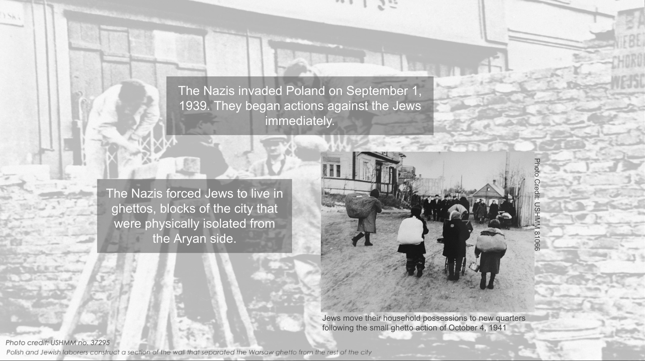
Figure 1.

The digital exhibit will be split into five sections. The first will contain an introduction explaining the start of the Holocaust and the Nazi movements toward Eastern Europe. It will also discuss how Jews were forced into ghettos. This will give context to the story about the start of female partisans and how most of the resistance in the ghettos were youth groups and run by teenagers. It will then provide a brief overview of the different resistance and partisans groups like the Bielski partisans, the Jewish Combat Organization (ZOB), and other local partisan groups before it delves into the individual stories in the next sections. Information will be displayed in text boxes on a background of historical pictures, whether it is a map of the ghettos or a picture of Jews building the ghetto walls (see fig. 1). The scrolling effect will be utilized as it is more accessible and aesthetically pleasing to the eye. This layout will run through the rest of the exhibit. There will also be other multimedia components such as a video that shows the modern city of Warsaw with ghetto walls superimposed on it (see fig. 2). This will provide readers with an understanding of how big the ghetto was and how many people lived there at any given time. When hearing about the Warsaw ghetto, one thinks of it as small and cramped into a few blocks, however it was quite large. To think of all the people the Nazis forced into it and add on the witnesses who testify that living conditions were overcrowded, one gets the idea of how many Jews the Nazis ghettoized in Warsaw.
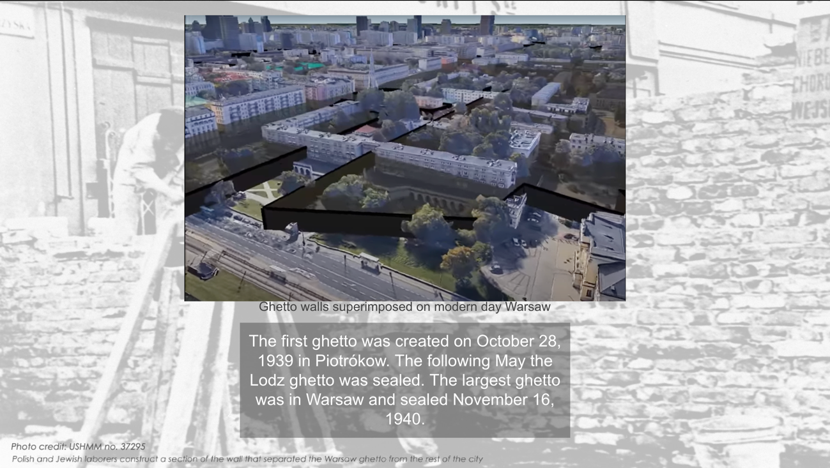
Video produced by 300gospodarka
Figure 2.

The subsequent three parts will depict the lives of three female partisans, Frumka Plotnicka, Vladka Meed, and Hannah Senesh. The exhibit will talk about the lives of the three women before the war, the events that led up to their partisan activities, and their heroic activities. The format for the stories of the three women will be short chunks of text easily digested by the reader. The second section will begin with the story of Frumka Plotnicka (see fig. 3). Frumka was born in 1914 into a Hassidic family. She was one of five children and the family lived in Belarus. As a teen, she joined the Zionist movement, He-Haluz, that trained Jews to live in Israel on kibbutzim or communal agricultural settlements. Plotnicka was supposed to emigrate to Israel in the summer of 1939 but was asked by the movement’s leadership to remain in Europe and became the emissary of the Warsaw branch. This was a decision that would decide her destiny. When the Nazis invaded Poland, the movement’s headquarters fled east toward Russia, but Frumka remained in Warsaw. While there, she became part of the underground and was chosen to remain on the Aryan side of the ghetto. Through this, she witnessed actions taken against the Jews and how the ghettos were systematically being liquidated. Frumka continuously disguised herself as a Pole, thanks to her Aryan features, to become a courier and travel to other Jewish ghettos bringing information about what she had witnessed and news about extermination camps all over Eastern Europe. She was sent to Będzin after the mass deportations began in Warsaw to lead the uprising there. She refused to leave her comrades even though she had multiple opportunities to be rescued but she ensured that the other members had passports if needed. Frumka Plotnicka was killed in the liquidation of the Będzin ghetto on August 1, 1943.

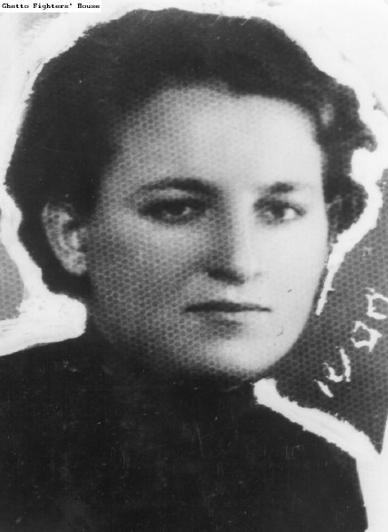
Figure 3. Frumka Plotnicka member of the Dror youth movement and the Jewish Fighting Organization in the Warsaw ghetto (photo courtesy of the Ghetto Fighters’ House Museum)

This section will include pictures, documents, and photographs of objects connected to Plotnicka. One of the photographs will be from the United States Holocaust Memorial Museum (USHMM) of a milk canister that held part of “Oneg Shabbat.” This was an archive put together by Dr. Emanuel Ringelblum that recorded daily life in the Warsaw ghetto. When the final deportations loomed closer the archives were buried in the ghetto to be uncovered by future generations. “Oneg Shabbat” is an important resource for scholars learning about ghetto life and a testimony of what occurred to the European Jewry during the war years. Frumka Plotnicka was like a living archive at the time. She witnessed the destruction of Jewish communities and she saw Jews being forced onto cattle cars and knew what their fate was. With this knowledge she traveled to other ghettos to warn them and bring them news they could not receive living in isolation. Her testimony about her missions was written in her last letter to colleagues already in Israel and a reproduction of this letter will be featured in this project from the Jewish Historical Institute. The authors of the letter were murdered, but copies of it survived the war and somehow made its way to a grandson of a doctor from Warsaw who had fled after the city was overrun by Nazis, to live in the Czech Republic.
Although reading the letter is not the same as oral history where the listener is able to gain a lot of information by watching and hearing the interviewee speak, it gives insight into the minds and feelings of the ghetto fighters. The reader feels the emotions of the writers as they list all their fellow fighters who were murdered. One cannot help noticing their blasé attitude to their fate, they had faced death numerous times already, which is enough to force the reader to confront uncomfortable truths. What would the reader have done in this situation? Would the reader have returned to ghettos to help their brethren fight the Nazis?
The third section will discuss Vladka Meed, whose real name was Feigele Peltel. Peltel lived in Warsaw with her traditional Jewish family. As a teen she was active in the local socialist movements and when the Nazis marched into Warsaw, she and her family were sealed inside the ghetto. Her father died of pneumonia and her mother, sister, and brother were deported to Treblinka. Peltel was left alone in the ghetto and was the sole survivor of her family. Vladka Meed, was chosen by the resistance to work on the Aryan side of the ghetto. What was her work? Part of it was to smuggle children out of the ghetto and find them safe houses. It was not easy to find places for these children. The right people had to be approached and for the right price, the ones who would not betray the Jewish children to the Nazis. She also smuggled in ammunition and guns to the other fighters. Meed met her husband Czeslaw Miedzyrzecka during the war and came to New York City on May 24, 1946. She dedicated her time in America to actively publicizing the events of the Holocaust and teaching it to educators to carry on to the next generation. She started and led the American Teachers’ Seminars on the Holocaust and Jewish Resistance as well as the Alumni Teacher Conference which do not exist anymore. Vladka Meed died on November 21, 2012, in Phoenix, Arizona.
A component of this section will be a picture of the Warsaw ghetto in ruins and an arrow will indicate to the user to pull the slider. When the slider is pulled to the right, the user will see archaeologists excavating the same site of the ruins and finding a child’s shoe. The shoe was excavated by the Warsaw Ghetto Museum, and they possess it at their institution. Although it is unclear who the shoe belonged to or whether the child survived the horrors of the war, it symbolizes Meed’s constant missions of smuggling Jewish children out of the ghetto.
Another element of the media featured in this section will include Vladka Meed’s false identification papers written in the name of Stanislawa Wachalska which is in the possession of USHMM. This ID allowed Vladka to live outside the ghetto and pretend to be a Polish girl. Living on the Aryan side gave Meed the opportunity to obtain bullets, dynamite, and guns which she then transferred to the ghetto. The head of the underground ordered Meed to continue acting as a Pole and not to partake in the uprising because she could be of future use. She was designated to bear testimony to the future of the heroic deeds of her comrades. Having this false identification card, Vladka could have forsaken the underground and continued hiding out to save herself. She could have acted as a Polish girl the whole time and not risked her life to go in and out of the ghetto, yet she chose to remain and help the Jews in the ghetto.
The fourth section depicts the life of Hannah Senesh who was born in Hungary in 1921. In 1939 already feeling antisemitic restrictions, she emigrated, alone, to Israel where she helped establish Kibbutz Sdot Yam. In 1943, hearing of the tragedy occurring in Europe, Hannah volunteered to become a paratrooper in the British army. Codenamed “Hagar,” her mission was to infiltrate behind enemy lines and make contact with local partisan groups. She gathered intelligence and aided allied pilots who had had to bail out of their planes in enemy territory. In 1944, she was dropped in Croatia where she worked with the partisans for a few months. She made her way to her native Hungary and was caught trying to cross the border in June 1944. The Hungarians imprisoned Senesh and tortured her to reveal information about her mission. Hannah Senseh was prosecuted as a British spy and a traitor to Hungary. She was executed in November 1944 at the age of 23, without revealing any information.
This section will show a picture of Hannah Senesh’s personal belongings such as her suitcase she used when she emigrated from Hungary to Israel in 1939. The suitcase, belonging to the National Library of Israel (NLI), represents the fact that Hannah was not imprisoned in Nazi occupied Europe. She had already escaped but chose to return to help her nation and family. She paid for her choice with her life. There will also be a picture, also part of the Senesh collection at the NLI, of the last note Senesh wrote to her mother, found in her pocket after her execution (see fig. 4). In it, she thanks her mother, and states that “words are not necessary.” When reading this the reader gets the feeling that Senesh is not about to apologize for her actions rather she believes she did what needed be done, whatever the consequences and with no fanfare.
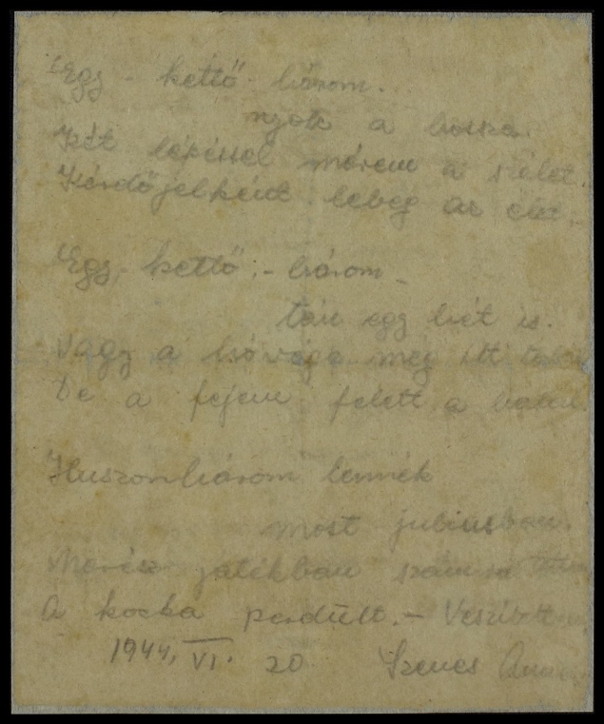
Figure 4. The Senesh Family Archive, with thanks to Ori and Mirit Eisen.

The concluding section will include a reflection of the acts of these women and explain what happened to the overall resistance movements. Were the movements effective in stopping the Nazi onslaught or did they make no difference? This section will go on to explain that there are two opinions among Holocaust scholars as how to define resistance. Was it armed force used against the Nazis? Or was it spiritual resistance, where the Jews did everything in their power to retain their values and dignity throughout the war? It will then explain further that armed resistance like the Warsaw Ghetto Uprising did hinder the Nazis for a short time. In 1943, when the Germans started another phase of deportation the members of the underground put up a fight leading to a temporary halt in liquidation. Thus, the Warsaw Uprising became an example for other ghettos to follow and launch their own resistance. Ultimately, the Jews were outnumbered, and overpowered by the Nazis and many members of the underground were murdered in the fighting. Other forms of resistance did occur regularly such as aiding neighbors and continuing to follow Jewish principles and tenets. If one considers this a form of resistance than the Jews engaged that front daily and were triumphed over the Nazis. This part will also have reflection questions that leave the reader with takeaways from this digital exhibit. A few questions would be “if you were a witness to injustice would you speak up? Would you act if there was a chance of bodily harm?” Would you save yourself in lieu of remaining and helping others?
Sources:
Among the key archival sources for this project is a small book that was found at the British Library. Titled “Freuen in di Ghettos” which translated from Yiddish means “Women in the Ghettos,” was found by author Judy Batalion in 2007. This book was put together in 1946 as a compilation of memoirs of the “ghetto girls” and published in New York, to notify the American Jewish community of these courageous stories of female fighters. It was not distributed as widely as hoped. Among the pages are stories of Jewish women who calmly walked up to Nazi officers and shot them and women who stole documents from their Gestapo employers. Many of these stories were not widely known even among the Jewish community. Upon reading their stories, Batalion wrote her own book to be a voice for these women and this book is the primary source for this digital project. “Freuen in di Ghettos” is not in publication anymore and has not been translated for the public or digitized. Part of this project will be to reprint it in English and digitize it which will increase it accessability.
Oral and written testimony are additional sources that provide a nuanced interpretation of events part of this exhibit. Reading Vladka Meed’s testimony, the reader gets the story in the words of the person themselves. Once the reader is turned into a listener it adds another layer to the story. One hears the accent and the inflections of the interviewee and empathizes along with her. The listener partakes in the silence with Meed trying to digest the information just heard; how Vladka was selected to stay in Warsaw and exploited for the German war effort and how her father died in the ghetto and her mother and siblings were deported to Treblinka. She was alone after that. This silence occurs again when the Vladka tells of watching the Warsaw ghetto in flames from the Polish side. She watched as the Jewish houses were torched and people jumped from the balconies. She witnessed her world, the place where she belonged, go up in flames. Listening to Vladka Meed and reading her testimony, gives the events a personal dimension and leaves the listener and/or reader in moments of reflection and introspection. The testimony will be part of the exhibit as well.
Opposition:
This digital exhibition is crucial in educating about the women who took part and were often the leaders of the resistance movements. Although this project is necessary it could be prone to opposition for several reasons. Opposition to this project could come from colleagues resenting that the focus is on women in this digital exhibit. While there have been strides made in the academic world, gender discrimination is still around in some form. Many female professors have noted that it is difficult to have their work published and it could take years until they see it in print. Other public historians find their expertise ignored or belittled because they are women. This means that their work and projects are not reaching a wide audience. This potentially can occur with Road of Resistance since it was researched by a woman, and it focuses only on female perspectives. Male colleagues might disregard this project and will not peruse it let alone recommend it to others as a source of information. For this project specifically, male historians are more likely to focus their research on the already publicized male resistance fighters like Mordechai Anielewicz, commander of the ZOB,who led the Warsaw ghetto uprising, or the Bielski brothers who led a major resistance group in Poland.
Holocaust scholars might oppose the definition and focus of resistance in this exhibit. In Holocaust studies there is a debate about what constitutes resistance, and this would influence the answer of whether Jews “went like sheep to the slaughter.” There are some scholars such as Raul Hilberg, the foremost Holocaust historian in his day, who defines resistance as armed force against oppressors. He notes that the lifestyle of Jews did not lend itself to this type of physical resistance. Hilberg does not disparage the resistance movements rather he believes that they were the outliers. They were the groups of mostly young adults who never conformed to the traditional Jewish lifestyle.
Professor Yehuda Bauer, another noted Holocaust scholar, does not only believe that resistance consists of physical elements, rather it could take form in other ways. He describes it as keeping “body and soul together.” This would mean that resistance could include smuggling, Jews helping others, and upholding their religious tenets and commandments to the best of their ability. This exhibit’s focus only covers physical resistance because it must cap the information at some level.
Public Reaction:
Public reaction to this project might also be diverse depending on the audience. In today’s environment where women’s voices are screaming to be heard, there will be a favorable reaction by other women. Women are still attempting to show the patriarchal society that they can perform just as successfully and even more successfully than their male counterparts. This digital project describes activities that often men were not able to do. They were too conspicuous physically, as Jews and did not speak Polish due to their learning in a religious school in their elementary years. Women, on the other hand, had no such problems. They were not physically identified as Jews. They also spoke Polish more fluently because they went to public schools. This exhibit highlights the women’s acts of heroism and will be favorable to the female public. It will show women the heights they can reach and how they can act in the face of injustice.
Although women will appreciate this project, it might not be seen as favorably in Poland. Public history projects, as this one, “reevaluate the facts.” Delving into Poland’s murky past with the Nazis can potentially unearth new information or reinterpret preexisting knowledge about the relationship between the Poles and the Nazis. After the war with the Russians occupying Poland, things that occurred during the war were kept quiet and many Poles would rather it be kept that way. Furthermore, the Polish government has classified speech stating they were complicit with the Nazis as a civil offense punished with a fine which was decreased from a criminal offense where offenders would have faced jail time. This digital exhibit features two out of three women who participated in resistance efforts in Poland. New research can come to the surface that might provide evidence against Poland hence their opposition to this project.
Unfortunately, there are also people who deny that the Holocaust occurred. These people might challenge this project. Believing that the Jews lied about their suffering, although not explaining where 6 million Jews disappeared to, Holocaust deniers might claim that this project is false and worthless. This has the potential to limit the exhibits audience.
Logistical Problems:
Besides for negative reactions, other problems may occur with this digital exhibit such as logistical implementation. The design for this digital project is similar to a digital exhibit from the Tenement Museum called Brick by Brick the Many Lives of 103 Orchard Street. This is not the type of digital exhibit where pictures are taken of a physical exhibit and digitized so viewers can click on the arrows to navigate and on icons to look at the pieces up close. The criteria for design are very specific thereby making it difficult to create. In order to implement, one needs to be proficient in specific software such as Vev. The specialized jobs may be hard to fill and delay the project.
Development Plan:
A crucial place to start the development plan for this project is with education. The project is invested in bringing these women’s lives into the spotlight so there needs to be an aggressive approach in outreach and further research. There are a few collaborations that can help Road of Resistance reach its potential audience, internationally and nationally.
The first collaboration to target global audiences would be with an upcoming exhibit at the POLIN Museum of the History of Polish Jews. 2023 marks eighty years since the Warsaw Ghetto Uprising. While not all the subjects of the digital exhibit participated in the uprising it has become a symbol of Jewish resistance against the Nazis. The exhibit titled “Around us a Sea of Fire. The Fate of Jewish Civilians during the Warsaw Ghetto Uprising” discusses what life was like in the ghetto but from the standpoint of the average Jews hiding in a bunker, not specifically members of the resistance and not from women. The museum also asks a series of leading questions connected to topics covered in Road of Resistance such as “[h]ow do we behave in the face of death? Where is the line between struggling to survive and surrendering?” This exhibit is in person only and does not pull out the women’s stories, so this project can appear simultaneously online and give the female perspective in the ghetto. The POLIN Museum is a highly accredited European Museum with multiple other programs that reach global audiences. Collaborating with them will ensure that Road of Resistance will gain attention internationally.
Another option for collaboration and outreach that targets American audiences is to partner with the United States Holocaust Memorial Museum. USHMM has recently started a Digital Humanities Associate Fellowship program to increase their digital strategies and outreach. The program wishes “to increase across capacity for expanding the application of digital techniques across institutions and the field of Holocaust and Genocide Studies.” Fellows also conduct their own research projects, and this digital exhibit can be an option for them to research.
The third option for outreach is to coordinate with the Jewish Partisan Educational Foundation. The foundation has the same goals as this project: to tell the world about the number of partisans and their daring acts during the war. They have even created a curriculum to teach about this topic. Partnering with this institution would allow for this digital project to be incorporated into their curriculum and disseminated into numerous classrooms.
Funding:
There are a few of choices for funding for this project. The New York State Council on the Arts offers funds to museums to continue their “cultural and heritage activities.” This council already has a relationship with Holocaust museums and has funded a few exhibitions like the newest one at the Museum of Jewish Heritage named The Holocaust: What Hate Can Do. Another possibility for funding can come from the Claims Conference, a nonprofit organization that originated with reclaiming stolen property and assets for Jewish victims. They have branched out into “support[ing] projects that further Shoah education, documentation, research, and film.”
Additionally, Road of Resistance looks to secure funding from the International Holocaust Remembrance Alliance (IHRA). IHRA has a few criteria that must be met in order to obtain a grant. The first is to “safeguard the record of the Holocaust…and to counter distortion.” The other objective is that the project must “develop educational approaches that enhance awareness of the continuing relevance of the Holocaust…for the present and the future.” Road of Resistance fulfills both objectives by highlighting the stories of women who led and participated in resistance activities against the Nazis which “enhances awareness.” It also gives the public previously unheard stories of these women and is relevant by showing modern women that they too can be leaders in change or stand up to injustice.
Obtaining federal funds might be another way to create this project. In 2020 President Trump signed the Never Again Education Act into law which designates funds to expand USHMM’s reach across the country. Done in the hope of combatting antisemitism, these funds will go towards establishing an online archive about the Holocaust for educators. This digital repository can include Road of Resistance for teachers to incorporate the topic of women partisans into their curriculums. Using these funds to aid this project will not only help it get off the ground but will give a valuable resource in increasing Holocaust awareness across the country.
The digital exhibit Road of Resistance: Three Women’s Journeys in defying the Nazis was created to tell the stories of the Jewish female resistance fighter during the Holocaust. It will also analyze the recurring theme of return, how the women had their own opportunities to escape Nazi Europe but chose to help their Jewish brethren instead. This project is meant to educate and fill the void of basic knowledge of the Holocaust. The digital exhibit is split into five sections and will be accessible to subscribers via email and nonsubscribers through the collaborating museums’ websites. This digital platform will enable the national as well as the global community to learn about Jewishwomen’s major role in the resistance movements across Europe during the Holocaust.

Bibliography
Ambrosewicz, Jolanta. “The Challenges of New Work in history and Education about the Holocaust in Poland.” In New Directions in the History of Jews in Polish Lands, edited by Antony Polonsky, Hanna Wegrzynek, and Andrzej Żbikowski, 170-182. Boston: Academic Studies Press, 2018. .https://www.degruyter.com/document/doi/10.1515/9788394914912-021/html?lang=en
Batalion, Judy. “The Nazi-Fighting Women of the Jewish Resistance.” The New York Times, March 18, 2021. https://www.nytimes.com/2021/03/18/opinion/sunday/Jewish-women-Nazi-fighters.html.
Batalion, Judy. “Why the Stories of Jewish Women Who Fought the Nazis Remained Hidden for So Long.” Time, April 8, 2021. https://time.com/5953135/hidden-history-jewish-women-fought-nazis/.
Berger, Joseph. “Vladka Meed, Who infiltrated Warsaw Ghetto, Dies at 90.” The New York Times, November 24, 2012. https://www.nytimes.com/2012/11/25/world/vladka-meed-who-infiltrated-warsaw-ghetto-dies-at-90.html
Butler, Deidre. “Holocaust Studies in the United States.” Jewish Women’s Archive, December 31, 1999. https://jwa.org/encyclopedia/article/holocaust-studies-in-united-states.
Claims Conference. “First-Ever-50-State Survey On Holocaust Knowledge of American Millennials and Gen Z Reveals Shocking Results.” Accessed October 22, 2022. https://www.claimscon.org/millennial-study/.
Claims Conference. “New Survey by the Azrieli Foundation and the Claims Conference Finds Critical Gaps in Holocaust Knowledge.” Accessed October 22, 2022. https://www.claimscon.org/study-canada/.
Claims Conference. “Shoah Education, Documentation, Research, and Film. Accessed October 27, 2022. https://www.claimscon.org/our-work/allocations/.
Ingber, Sasha. “Poland Backtracks on a Controversial Holocaust Speech Law.” NPR, June 27, 2018. https://www.npr.org/2018/06/27/623865367/poland-backtracks-on-a-controversial-holocaust-speech-law.
International Holocaust Remembrance Alliance. “Funding.” Accessed December 4, 2022. https://www.holocaustremembrance.com/resources/funding
Jewish Partisans Educational Foundation. “About JPEF.” Accessed October 27, 2022. https://www.jewishpartisans.org/what-is-jpef.
Jewish Partisans Educational Foundation. “Jewish Women in the Partisans.” Accessed September 8, 2022. https://www.jewishpartisans.org/content/jewish-women-partisans.
Jewish Partisans Educational Foundation. “Partisans & Countries.” Accessed October 24, 2022. https://www.jewishpartisans.org/countries/europe.
Koschalka, Ben. “Warsaw Ghetto Archaeologists Find Children’s Shoes and Books.” Notes from Poland, July 13, 2022. https://notesfrompoland.com/2022/07/13/warsaw-ghetto-archaeologists-find-childrens-shoes-and-books/.
Marrus, Michael R. “’Good History’ and Teaching the Holocaust.” Perspectives in History, May 1, 1993. https://www.historians.org/research-and-publications/perspectives-on-history/may-1993/good-history-and-teaching-the-holocaust.
Meed, Vladka. “Oral History Testimony.” Interview by Mildred Finger. William E. Wiener Oral History Library of the American Jewish Committee at New York Public Library, December 1981, February 1982. https://digitalcollections.nypl.org/items/7c7ba520-02df-0131-5a8f-58d385a7b928#/?uuid=7d210630-02df-0131-5923-58d385a7b928.
Meed, Vladka. “Testimony.” Interview by Renee Firestone. USC Shoah Foundation, May 15, 1996. Video. https://www.youtube.com/watch?v=nKLeGBfyrJA.
Naor, Amit. “Hannah Senesh’s Last Note.” Times of Israel, December 2, 2020. https://blogs.timesofisrael.com/hannah-seneshs-last-note/.
National Council on Public History. “The Changing Past.” Accessed November 10, 2022. https://ncph.org/what-is-public-history/how-historians-work/the-changing-past/.
National Library of Israel. “Briefcase.” The Senesh Family Archive, with Thanks to Ori and Mirit Eisen. Accessed November 18, 2022. https://www.nli.org.il/en/archives/NNL_ARCHIVE_AL997009902788405171/”NLI#$FL172345083.
National Library of Israel. “Hannah Senesh.” Accessed September 8, 2022. https://www.nli.org.il/en/discover/history/figures/hannah-szenes.
National Library of Israel. “Last Song.” The Senesh Family Archive, with Thanks to Ori and Mirit Eisen. Accessed November 18, 2022. https://www.nli.org.il/en/archives/NNL_ARCHIVE_AL997009911867605171/NLI#$FL173406696.
New York State Council on the Arts. “Museum.” Accessed October 28, 2022. https://arts.ny.gov/funding-areas/museum.
POLIN Museum of the History of Polish Jews. “Around the Sea of Fire. The Fate the Jewish Civilians During the Warsaw Ghetto Uprising Exhibition.” Accessed October 22, 2022. https://polin.pl/en/around-us-a-sea-of-fire-exhibition.
POLIN Museum of the History of Polish Jews. “European Museum Academy Prize Awarded to POLIN Museum.” November 8, 2016. https://www.polin.pl/en/news/2019/06/10/european-museum-academy-prize-awarded-polin-museum-0.
Portland State University. “Inclusive Citation, Inclusive Academy Webinar.” June 30, 2020. https://guides.library.pdx.edu/c.php?g=527355&p=3623937%20.
Prifogle, Emily and Karin Wolf. “Why Women Also Know History.” Journal of Women’s History 32, no. 2 (2020): 113-117. https://repository.law.umich.edu/cgi/viewcontent.cgi?article=3550&context=articles
Richman, Jackson. “Trump Signs into Law the Never Again Education Act. JNS. May 30, 2020. https://www.jns.org/trump-signs-never-again-education-act-into-law/
Ringelblum, Emanuel. Notes from the Warsaw Ghetto. Translated by Jacob Sloan. New York: McGraw-Hill Book Company Inc., 1958.
Sajdak, Aleksandra. “The Last Letter from Będzin.” Jewish Historical Institute. Accessed October 1, 2022. https://www.jhi.pl/en/articles/the-last-letter-from-bedzin,19.
Saidel, Rochelle G. “Vladka Meed.” Jewish Women’s Archive. December 31, 1999. https://jwa.org/encyclopedia/article/meed-vladka
Shimshi, Naomi. “Frumka Plotnicki.” Jewish Women’s Archive. December 31, 1999. https://jwa.org/encyclopedia/article/plotniczki-frumka#pid-1397.
Silver Ochayon, Sheryl. “The Female Couriers During the Holocaust.” Yad Vashem. Accessed September 27, 2022. https://www.yadvashem.org/articles/general/couriers.html#footnote2_i400pip.
Simko, Riley. “Women’s Christian Temperance Movement.” Encyclopedia of Cleveland History. Case Western University. Accessed November 19, 2022. https://case.edu/ech/articles/w/womens-christian-temperance-movement#:~:text=The%20NATIONAL%20WOMEN'S%20CHRISTIAN%20TEMPERANCE,pray%2Dins%20at%20local%20taverns.
Steptoe, Tyina. “Wells-Barnett, Ida B.” Social Welfare Project. Virginia Commonwealth University. Accessed November 19, 2022. https://socialwelfare.library.vcu.edu/eras/civil-war-reconstruction/wells-barnett-ida-b/.
United States Holocaust Memorial Museum. “Armed Jewish Resistance: Partisans.” Holocaust Encyclopedia. March 2, 2022. https://encyclopedia.ushmm.org/content/en/article/armed-jewish-resistance-partisans.
United States Holocaust Memorial Museum. “Digital Humanities Associate Fellowship.” Accessed October 27, 2022. https://www.ushmm.org/research/opportunities-for-academics/fellowships/digital.
United States Holocaust Museum. “False Identification Card Issued in the Name of Stanislawa Wachalska, that was used by Feigele Peltel (now Vladka Meed) While Serviing as a Courier for the Jewish Underground in Warsaw.” Accessed November 18, 2022. https://collections.ushmm.org/search/catalog/pa1128201.
United States Holocaust Museum. “One of the Three Milk Cans Used by Warsaw Ghetto Historian Emanuel Ringelblum to Store and Preserve the Secret ‘Oneg Shabbat’ Ghetto Archives.” Accessed November 18, 2022. https://collections.ushmm.org/search/catalog/pa1092486.
Warsaw Ghetto Museum. “Excavations in the Former Warsaw Ghetto.” June 15, 2022. http://1943.pl/en/artykul/archaeological-research-in-the-area-of-the-former-warsaw-ghetto/.
Yad Vashem. “One of Ten Metal Containers in Which ‘Oneg Shabbat” Archive was Hidden. Accessed November 18, 2022. https://www.yadvashem.org/artifacts/museum/oneg-shabbat-archive.html.
Yad Vashem. “Warsaw Ghetto Uprising.” Accessed November 17, 2022. https://www.yadvashem.org/holocaust/about/combat-resistance/warsaw-ghetto.html.

Deidre Butler, “Holocaust Studies in the United States,” Jewish Women’s Archive, December 31, 1999, https://jwa.org/encyclopedia/article/holocaust-studies-in-united-states
Sheryl Silver Ochayon, “The Female Couriers During the Holocaust,” Yad Vashem, accessed September 27, 2022, https://www.yadvashem.org/articles/general/couriers.html#footnote2_i400pip.
Judy Batalion, “Why the Stories of Jewish Women Who Fought the Nazis Remained Hidden for so Long,” Time, April 8, 2021, https://time.com/5953135/hidden-history-jewish-women-fought-nazis/.
Rily, Simko, “Women’s Christian Temperance Movement,” Encyclopedia of Cleveland History, Case Western University, accessed November 19, 2022, https://case.edu/ech/articles/w/womens-christian-temperance-movement#:~:text=The%20NATIONAL%20WOMEN'S%20CHRISTIAN%20TEMPERANCE,pray%2Dins%20at%20local%20taverns; Tyina Steptoe,“Wells-Barnett, Ida B.,” Social Welfare Project, Virginia Commonwealth University, accessed November 19, 2022, https://socialwelfare.library.vcu.edu/eras/civil-war-reconstruction/wells-barnett-ida-b/.
“Jewish Women in the Partisans,” Jewish Partisan Educational Foundation, accessed September 8, 2022, https://www.jewishpartisans.org/content/jewish-women-partisans.
“Partisans and Countries,” Jewish Partisan Educational Foundation, accessed October 24, 2022, https://www.jewishpartisans.org/countries/europe.
“First-Ever-50-State Survey On Holocaust Knowledge of American Millennials and Gen Z Reveals Shocking Results,” Claims Conference, accessed October 22, 2022, https://www.claimscon.org/millennial-study/.
Ibid.
“New Survey by the Azrieli Foundation and the Claims Conference finds Critical Gaps in Holocaust Knowledge,” Claims Conference, accessed October 22, 2022, https://www.claimscon.org/study-canada/.
Ben Koschalka, “Warsaw Ghetto Archaeologists Findn Children’s Shoes and Books,” Notes from Poland, July 13, 2022, https://notesfrompoland.com/2022/07/13/warsaw-ghetto-archaeologists-find-childrens-shoes-and-books/.
Naomi Shimshi, “Frumka Plotnicki,” Jewish Women’s Archive, December 31, 1999, https://jwa.org/encyclopedia/article/plotniczki-frumka#pid-1397.
Silver Ochayon, “Female Couriers.”
Shimshi, “Plotnicki.”
“One of the Three Milk Cans Used by Warsaw Ghetto Historian Emanuel Ringelblum to Store and Preserve the Secret ‘Oneg Shabbat’ Ghetto Archive,” United States Holocaust Museum, accessed November 18, 2022. https://collections.ushmm.org/search/catalog/pa1092486
“One of Ten Metal Containers in which “Oneg Shabbat” Archive was Hidden,” Yad Vashem, accessed November 18, 2022, https://www.yadvashem.org/artifacts/museum/oneg-shabbat-archive.html.
Silver Ochayon. “Female Couriers.”
Emanuel Ringelblum, Notes from the Warsaw Ghetto, trans. Jacob Sloan (New York: McGraw-Hill, 1958).
Aleksandra Sajdak, “The Last Letter from Będzin,” Jewish Historical Institute, accessed October 1, 2022, https://www.jhi.pl/en/articles/the-last-letter-from-bedzin,19
Vladka Meed, “Oral History Memoir,” interview by Mildred Finger, William E. Wiener Oral History Library of the American Jewish Committee, New York Public Library, December 30, 1981, February 18,1982 https://digitalcollections.nypl.org/items/7c7ba520-02df-0131-5a8f-58d385a7b928#/?uuid=86a2c920-02df-0131-853e-58d385a7b928.
Rochelle G. Saidel, “Vladka Meed,” Jewish Women’s Archive, December 31, 1999, https://jwa.org/encyclopedia/article/meed-vladka.
Koschalka. “Warsaw Ghetto Archaeologists.”
“Excavation in the Former Warsaw Ghetto Area,” Warsaw Ghetto Museum June 15, 2022, http://1943.pl/en/artykul/archaeological-research-in-the-area-of-the-former-warsaw-ghetto/.
“False Identification Card Issued in the Name of Stanislawa Wachalska, that was Used by Feigele Peltel (now Vladka Meed) while Serving as a Courier for the Jewish Underground in Warsaw,” United States Holocaust Museum, accessed November 18, 2022, https://collections.ushmm.org/search/catalog/pa1128201.
Joseph Berger, “Vladka Meed, Who Infiltrated Warsaw Ghetto, Dies at 90,” New York Times, November 24, 2012, https://www.nytimes.com/2012/11/25/world/vladka-meed-who-infiltrated-warsaw-ghetto-dies-at-90.html
“Hannah Senesh,” National Library of Israel, accessed September 8, 2022, https://www.nli.org.il/en/discover/history/figures/hannah-szenes.
“Briefcase,” The Senesh Family Archive, with Thanks to Ori and Mirit Eisen, National Library of Israel, accessed November 18, 2022, https://www.nli.org.il/en/archives/NNL_ARCHIVE_AL997009902788405171/NLI#$FL172345083.
“The Last Song,” The Senesh Family Archive, with Thanks to Ori and Mirit Eisen, National Library of Israel, accessed November 18, 2022, https://www.nli.org.il/en/archives/NNL_ARCHIVE_AL997009911867605171/NLI#$FL173406696.
Amit Naor, “Hannah Senesh’s Last Note,” Times of Israel, December 2, 2020, https://blogs.timesofisrael.com/hannah-seneshs-last-note/.
“Warsaw Ghetto Uprising,” Yad Vashem, accessed Novemer 17, 2022, https://www.yadvashem.org/holocaust/about/combat-resistance/warsaw-ghetto.html.
“Armed Jewish Resistance: Partisans,” Holocaust Encyclopedia, United Stated Holocaust Memorial Museum, March 2, 2022, https://encyclopedia.ushmm.org/content/en/article/armed-jewish-resistance-partisans
Judy Batalion, “The Nazi-Fighting Women of the Jewish Resistance,” The New York Times, March 18, 2021, https://www.nytimes.com/2021/03/18/opinion/sunday/Jewish-women-Nazi-fighters.html
Vladka Meed, “Testimony,” interview by Renee Firestone, USC Shoah Foundation, May 15, 1996, video, https://www.youtube.com/watch?v=nKLeGBfyrJA.
“Inclusive Citation, Inclusive Academy Webinar,” Portland State University, June 30, 2020, https://guides.library.pdx.edu/c.php?g=527355&p=3623937%20.
Emily Prifogle and Karin Wolf, “Why Women Also Know History,” Journal of Women’s History 32, no. 2 (2020): 113-117, https://repository.law.umich.edu/cgi/viewcontent.cgi?article=3550&context=articles.
Michael R. Marrus, “’Good History’ and Teaching the Holocaust,” Perspectives in History, May 1, 1993, https://www.historians.org/research-and-publications/perspectives-on-history/may-1993/good-history-and-teaching-the-holocaust.
Ibid.
Silver Ochayon, “Female Couriers.”
“The Changing Past,” National Council on Public History, accessed November 10, 2022, https://ncph.org/what-is-public-history/how-historians-work/the-changing-past/.
Jolanta Ambrosewicz, “The Challenge of New Work in History and Education about the Holocaust in Poland,” in the New Directions in History of the Jews in Polish Lands, ed. Antony Polonsky, Hanna Wegrzynek, and Andrzej Żbikowski (Boston: Academic Studies Press, 2018), 170-182. https://www.degruyter.com/document/doi/10.1515/9788394914912-021/html?lang=en.
Sasha Ingber, “Poland Backtracks on a Controversial Holocaust Speech Law,” NPR, June 27, 2018, https://www.npr.org/2018/06/27/623865367/poland-backtracks-on-a-controversial-holocaust-speech-law.
“Around The Sea of Fire. The Fate of Jewish Civilians During the Warsaw Ghetto Uprising Exhibition,” POLIN Museum of the History of Polish Jews, accessed October 22, 2022, https://polin.pl/en/around-us-a-sea-of-fire-exhibition.
“European Museum Academy Prize Awarded to POLIN Museum,” POLIN Museum of the History of Polish Jews, November 8, 2016, https://www.polin.pl/en/news/2019/06/10/european-museum-academy-prize-awarded-polin-museum-0.
“Digital Humanities Associate Fellowship,” United States Holocaust Memorial Museum, accessed October 27, 2022, https://www.ushmm.org/research/opportunities-for-academics/fellowships/digital
“About JPEF,” Jewish Partisans Educational Foundation, accessed October 27, 2022, https://www.jewishpartisans.org/what-is-jpef
“Museum,” New York State Council on the Arts, accessed October 28, 2022. https://arts.ny.gov/funding-areas/museum
“Shoah Education, Documentation, Research, and Film,” Claims Conference, accessed October 27, 2022, https://www.claimscon.org/our-work/allocations/.
“Funding,” International Holocaust Remembrance Alliance, accessed December 4, 2022, https://www.holocaustremembrance.com/resources/funding.
Ibid.
Jackson Richman, “Trump Signs into Law the Never Again Education Act,” JNS, May 30, 2020, https://www.jns.org/trump-signs-never-again-education-act-into-law/.

